

**KYUNGDONG UNIVERSITY (KDU)**

**SOUTH KOREA**

**HOTEL ROOM BOOKING SYSTEM**

**Database Management System Project- Phase 1**

**Bachelor of Smart computing (4th semester)**

**Prepared by: Submitted to:**

**Lama Amit (1724045) Prof. Dr.Ahmed Absi**

**Dahit Santosh (1724044) Asst. Dean of KDU Global**

**Submission On:**

**2019/04/10**

**Abstraction**

This is the document of the project for developing a hotel management system for a hotel. It consists of the current background of the hotel and problems having due to present system and how this proposed system overcome those matters.

Mainly the project aims to build a system for managing the reservation of hotel rooms. We are going to use Microsoft SQL database for database purpose. This system will be able to add, delete and update the room, customer details and transaction. This system will become an alternative way of storing the details of rooms, guest in easy way. Customer or guest can easily get and manage the room. It will find a solution for calculating the bill automatically.

Abstraction ………………………………………………………………………I

Table of Contents……………………………………………………II

Contents

1. Introduction………………………………………………………….1

1.1. About the project……………………………………………..1

1.2. Objectives …………………………………………………….2

1.3 Scope………………………………………………………….3

1.4. Features………………………………………………………..3

2. Requirement Analysis………………………………………………..4

2.1. System Analysis……………………………………………….4

2.1.1. EXISTING SYSTEM…………………………………...4

2.1.2. Proposed System………………………………………..4

2.2. Feasibility Analysis……………………………………………5

2.2.1. Technical feasibility…………………………………….5

2.3. Functional Requirement Analysis……………………………..5

2.4. Non-functional Requirement Analysis………………………...5

2.5. System requirements…………………………………………..6

a. Hardware Requirement………………………………….6

b. Software Requirements ………………………………...6

c. User Interface…………………………………………...6

3. System Design ………………………………………………………7

3.1. Entities and their attributes…………………………………….7

a. Customer………………………………………………..7

b. CreditCard………………………………………………8

c. Payment……………………………………………….8-9

d. Booking…………………………………………………9

e. Rooms…………………………………………………10

f. Room Category………………………………………..10

g. Booking Details………………………………………..11

3.2. Relationship…………………………………………………..12

4. Conceptual database model………………………………………….13

5. Entity relationship diagram………………………………………….14

6. Conclusion…………………………………………………………..15

1. **Introduction** 
   1. **About the project**

As the current system might be a file based management system or manual system for which hotel staff should put much effort on recording and securing those files. They can be easily get damaged by a fire, insects or even by a natural disaster. Keeping files take much time and wastes much precious man hours. We can’t be sure for accuracy of calculation done by manually; even we need calculator for small calculation. If we want to check a room record or reservation of room details, management might face great problem while checking the records.

The Hotel Room Management System is going to implement will be covering all the basic processes done in hotel in systematic and effective way. It will record all details and calculation functionality. It will handle customer details, inventory management details, Room Service details, and room types.

All these details and information are stored in system database. It could save time when retrieving data from database. Interfaces will be designed user friendly and the functions will be displayed in a simpler manner. Customers don’t need to visit the hotel for reservation earlier.

We decide to develop their reservation system as computer based system and hotel can give quick service for guests.

* 1. **Objectives**
* **Developing hotel reservation system solution.**
* Customers can easily go online with their mobile phones or laptops to browse about hotels.
* Guests can be able to book for rooms within their budgets after seeing and accessing these hotels within their vicinity.
* Develop database which stored details about guest and hotel rooms when they entered.
* Create an easy way to understand user friendly environment.
* **The main objectives of the proposed system are to provide efficiency of day to day activities of Hotel like:**

1. Room activities,
2. Admission of a New Customer,
3. Assign a room according to customer’s demand,
4. Checkout of a computer and releasing the room
5. Finally compute the bill etc.
6. Advance bookings.
7. Cancellation.
   1. **Scope**

This system provides the employee easy who works in the reception the ability to do reservation for the hotel guests: by searching for available rooms, inserting the guest information, making the reservation and the payment process. This system is build using Microsoft sql database.

This system will provide automation of reservation and billing system.

* 1. **Features**

This project has some more features:

**•** No data duplication

• No Paper Work Required

• Time Efficient

• Cost Efficient

• Automatic data validation

• User friendly environment

• Data security and reliability

• Fast data insertion & retrieval

• Easy performance check.

1. **Requirement Analysis**
   1. **System Analysis**
      1. **EXISTING SYSTEM:**

The existing system leads to a lot of problems. Daily transactions are maintained in journals. These journal entries are then posted on to the ledger accounts correspondingly.

It maintains huge records for various departments. The book keeping procedure is tedious and is prompt to errors. Very careful handling is needed in manual systems. Even a very minute mistake may lead to imbalanced results. Manual processes result in waste of time and energy.

* + 1. **Proposed System.**

Following properties would implement:

* This system maintains user’s personal info, address and contact details.
* This system makes the overall project management much easier and flexible.
* Various system has been used for maintaining the details of all the users and the catalog and user friendly.
* System is providing more memory for the users to maintain the data.
* Providing accessibility control data with respects to users.

This project integrates all Operation processes in the computer to operate the important resources of material and money.

* 1. **Feasibility Analysis**
     1. **Technical feasibility:**

**Database**: The data will be stored in Microsoft SQL Database. We will build the tables and their requirements as needed for controlling system.

* 1. **Functional Requirement Analysis:**
* Make Reservations
* Search Rooms
* Add Payment
* Manage Guest (Add, Update Guest)
* Manage room details (Add, Update, and Delete)
* Manage Staff (Add, update, Delete, View)
* Manage Inventory (Add, Edit, Delete)
* Manage Users (Add, Update, Delete)
  1. **Non-functional Requirement Analysis:**
* Recoverability- must recover any kind of issues.
* System Availability- must available 24*7 hrs. Without any obstacles.
* General Performance
* Capacity
* Security
* Reliability
* Maintainability
* Portability
* Standards Compliance-Consistency in variable names and graphical user interface will have consistent look and fell.
* Design Constrains – Based on windows environment and Microsoft SQL Database
  1. **System requirements:**

1. **Hardware Requirement:**

We haven’t decided the hardware requirement yet. But we assuming the following devices which will be suitable for our proposed system:

Processor : Dual Core 2.5GHZ

Monitor : 15” LCD Monitor

Ram : 1GB DDR 1

Hard Disk Drive : 160GB

Keyboard : TVS Electronics

Mouse : Front tech

1. **Software Requirements:**

Processor : Intel Pentium processor,800 MHz

Operating System : Windows 7 or above

Database : Microsoft SQL Database

1. **User Interface:**
   * + Booking
     + Check-in
     + Check-out
     + Payment
     + Room Type
     + Room Details
     + Customer Details
     + Admin User
     + Admin Rooms

Phase-2 (implementation)

* + - Admin Record
    - Reports

1. **System Design** 
   1. **Entities:**
2. **Customer:**



|  |  |  |
| --- | --- | --- |
| C_ID | nchar(10) | not null  Primry Key |
| C_FirstName | varchar(50) | not null |
| C_LAstName | varchar(50) | not null |
| Phone_Num | varchar(50) | not null |
| Address | varchar(50) | not null |
| Email | varchar(50) | null |

1. **CreditCard:**



Primary Key

|  |  |  |
| --- | --- | --- |
| CreditCard_No. | nchar(10) | not null |
| Card_Name | varchar(50) | not null |
| Card_Expir | nchar(10) | not null |

1. **Payment:**



|  |  |  |
| --- | --- | --- |
| Payment_ID | nchar(10) | not null  Primary Key |
| CreditCard_No | nchar(50) | not null |
| B_ID | nchar(10) | not null  Foreign Key |
| Toyal_Price | money | not null |
| Payment_Mode | varchar(50) | not null |
| Payment_Date | date | not null |

1. **Booking:**



Primary Key

|  |  |  |
| --- | --- | --- |
| B_ID | nchar(10) | not null |
| Check_In | varchar(50) | not null |
| Check_Out | varchar(50) | not null |
| Total_Room | nchar(10) | not null  Foreign Key |
| C_ID | nchar(10) | not null |
| Pay_Status | varchar(50) | not null |

1. **Rooms:**



Primary Key

|  |  |  |
| --- | --- | --- |
| R_ID | nchar(10) | not null |
| RC_ID | nchar(10) | not null  Foreign key |

1. **Room Category:**



|  |  |  |
| --- | --- | --- |
| RC_ID | nchar(10) | not null  Primary Key |
| Category | varhar(50) | not null |
| R_Price | money | not null |

1. **Booking Details:**



Primary Key

|  |  |  |
| --- | --- | --- |
| RB_ID | nchar(10) | not null |
| R_ID | nchar(10) | not null  Foreign Key |
| B_ID | nchar(10) | not null |
| RC_ID | nchar(10) | not null |
| Check_In | varhar(50) | not null |
| Check_Out | varhar(50) | not null |
| Total_Days | nchar(10) | not null |
| Total_Price | money | not null |

* 1. **Relationship:**

1. The relationship between Customers to Payment is one to many.
2. The relationship between to customer is one to one.
3. The relationship between Category to Booking Detail is one to many
4. The relationship between Booking to Booking Details is one to one
5. The relationship between Room status to Room Category is one to one
6. The relationship between Payments to transaction is one to one.
7. The relationship between Payments to payment Modes is one to one.

**Short form used:**

R_ID: room id

RC_ID: room category id

B_ID: Booking id

RB_ID: room booking id

C_ID: customer id

1. **Conceptual database diagram model:**

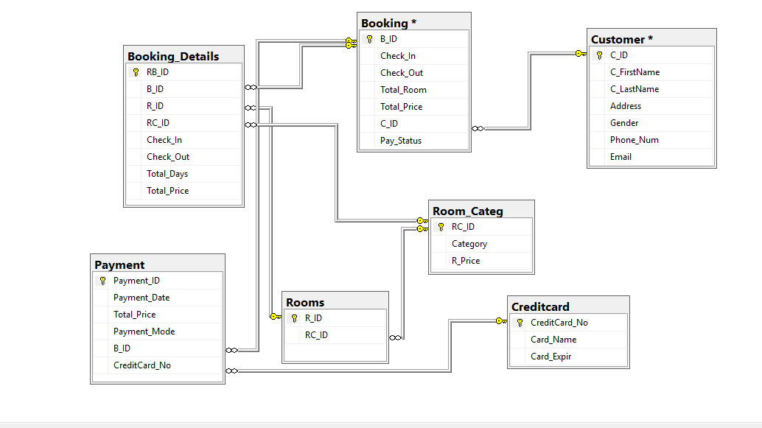

1. **Entity relationship diagram**



**Implementation and testing:** We will show in phase -2

1. **Conclusion:**

This management system is all about for reservation room of any hotels. Any hotels can use this system easily in effective and smooth manner. They can fell very easy with this system to record the daily details of customer and the hotels.

This system gives the information or details about all customers who have visited and who are checking for room in regarding hotels.

For database purpose, we are using Microsoft SQL database which is more effective system to store the records of any system. This database helps to store high volume of information with clear and specified details, if we keep clear or proper details about the consumer or customer by a user.

This system allows the customer to check room availability, room category, room price and user can collect all the details about customer in this system.

The Hotel Management System, going to implement, will be covering all the basic processes done in hotel in systematic, technically and effective way. Developing hotel reservation system and Create an easy way to understand user friendly environment.

**References:**

<https://www.scribd.com/doc/56442721/Hotel-Management-Doc>

<https://www.scribd.com/doc/63824633/Hotel-Management-System>

<https://www.scribd.com/doc/50636442/Hotel-Room-Booking-availability>

<https://www.slideshare.net/vidya_shankar/hotel-managementsystemcorrectfinalsrs>

<https://www.slideshare.net/thissagamage1/project-proposal-document-for-hotel-management-system>